Lesson Title/Focus | Communicating Feelings – Lesson 2 | Date | Wednesday November 13
Subject/Grade Level | Health – Grade 2 | Time Duration | 60 mins
Unit | Feelings | Teacher | Miss. Collier

OUTCOMES FROM ALBERTA PROGRAM OF STUDIES
General Learning Outcomes: | Relationship Choices:  Students will develop effective interpersonal skills that demonstrate responsibility, respect and caring in order to establish and maintain healthy interactions.  Understanding and Expressing Feelings
Specific Learning Outcomes: | R – 2.2 become aware that the safe expression of feelings is healthy
LEARNING OBJECTIVES
Students will:
- Identify upsetting feelings.
- Identify supportive adults.
- Name their feelings when being presented with various situations.
ASSESSMENTS
Observations: |  |  | - Observe answers students give to questions.  - Observe the feelings students use for their worksheet.
Key Questions: |  |  | - Who can you trust to talk to?  - What are different ways you can communicate your feelings?
Products/Performances: |  |  | - Today I feel Worksheet
LEARNING RESOURCES CONSULTED |  |  |  | MATERIALS AND EQUIPMENT
- Poster Lesson Resource |  |  |  | - Worksheets  - Pencils  - Crayons
PROCEDURE
Prior to lesson |  | Play a song on the computer. Welcome students. Organize agendas. Get students in their desks. Have them write a sentence in their agendas. When they are finished their agenda, have them meet me on the carpet.
Introduction |  |  |  |  | Time
Assessment of Prior Knowledge |  | Ask- Who can remind the class what we learnt yesterday? |  |  | 2 mins
Advance Organizer/Agenda |  | - Discuss  - Situations  - Discuss  - Worksheet
Body |  |  |  |  | Time
Learning Activity #1 |  | Discuss – What are some ways we can communicate feelings? Is it good to talk about our feelings with someone? Should we bottle up all our feelings inside?  -Show picture prompt. Ask students how they think Randy is feeling? Ask how they can tell that he’s feeling that way? How does it feel to talk with someone you trust? What can Randy say to his grandfather to tell him how he is feeling? What makes Randy’s grandfather a good person to talk to? Who are some people you trust? |  |  | 15 mins
Assessments/ Differentiation: |  | Listen to the student’s answers and see if they can properly identify trusted adults.
Learning Activity #2 |  | Situation Cards – Similar to yesterday, Pair students and give each student a situation card. Tell students that you want them to talk with their partner about how they would feel in this situation and who they would talk to about how they are feeling. Bring students back to carpet and have the pairs share their situation. Do an example as a class. Select students to repeat instructions back to you. |  |  | 10 mins
Assessments/ Differentiation |  | Observe the answers that students give when they share their situation card.
Learning Activity #3 |  | Discuss – Are there other ways to communicate your feelings? Do we only have to communicate bad feelings? Can we communicate good feelings with people? |  |  | 3 mins
Assessments/ Differentiation |  | Listen to the answers that are given.
Learning Activity #4 |  | ‘Today I Feel’ Worksheet – Explain to students that we are going to create a sheet that allows us to express our feelings without talking to someone, but rather showing them.  Create a list of feelings we can communicate on the board. Show an example so students get an understanding. Use 9 different emotions and draw the faces of how that emotion would look. |  |  | 25 mins
Assessments/ Differentiation |  | Assess what kind of feelings the students use for their worksheet.
Closure |  |  |  |  | Time
Assessment of Learning: |  |  | Ask students: Who can tell me some ways to communicate feelings?  Do we only have to communicate bad feelings? How are you going to use your “Today I feel” Worksheets? |  | 5 mins
Transition To Next Lesson

Sponge Activity/Activities | - More situation cards for students to look at and think about who they can talk to.  - Read, Write, Draw.

Reflections from the lesson

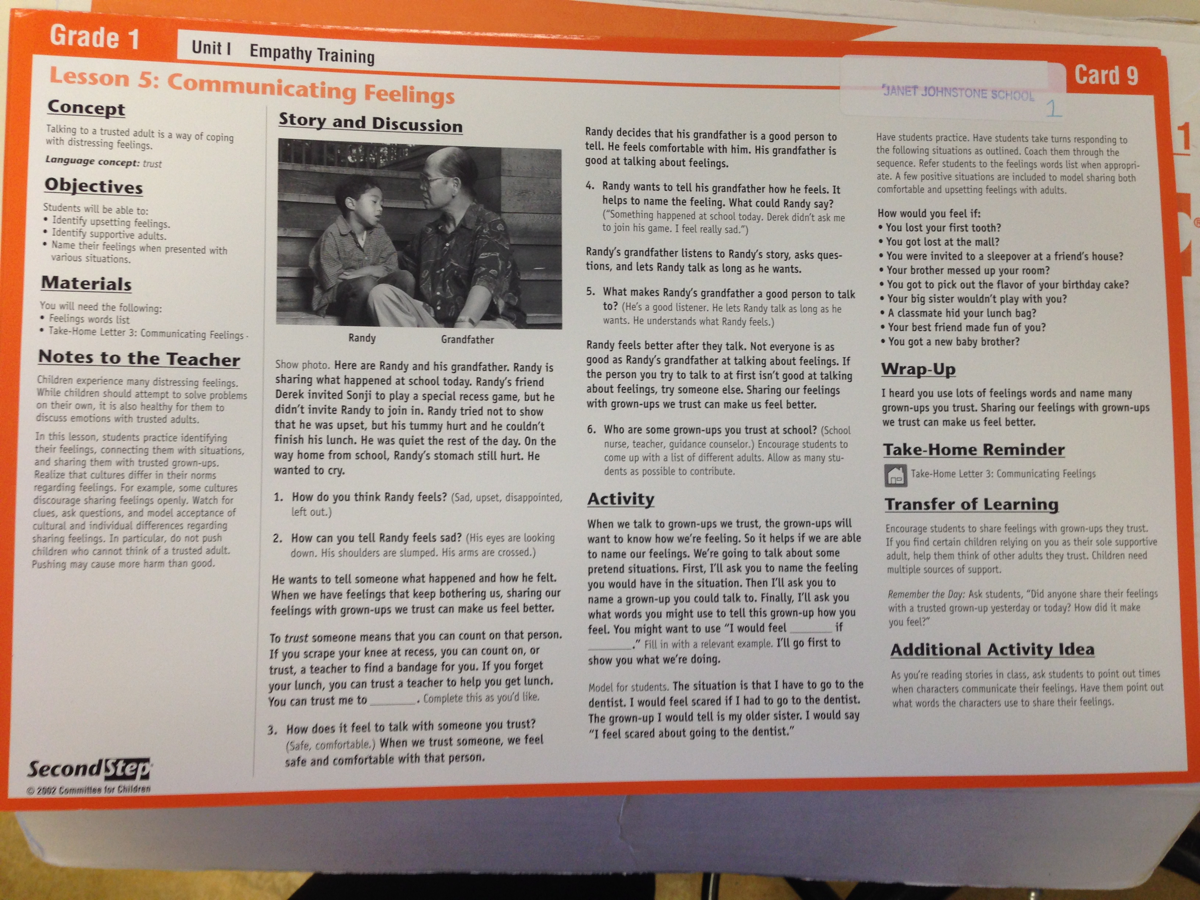

You’re getting sick with the flu.
How do you feel?
Who do you talk to?
You can’t find your boots at the end of the day.
How do you feel?
Who do you talk to?
Your best friend is moving away.
How do you feel?
Who would you talk to?
Your friend slipped on the ice outside on the playground.
How do you feel?
Who would you talk to?
You’re about to go on the biggest, fastest roller coaster in the world.
How do you feel?
Who would you talk to?
You’re on your way to the dentist.
How do you feel?
Who would you talk to?
You got 100% on your test.
How do you feel?
Who would you talk to?
You were invited to a sleepover at your friend’s house.
How do you feel?
Who would you talk to?
Someone pushed you to the ground at recess.
How do you feel?
Who would you talk to?

A classmate hid your lunch bag.
How do you feel?
Who would you talk to?
You got a new baby brother or sister.
How do you feel?
Who would you talk to?
You got lost at the mall.
How do you feel?
Who would you talk to?

_____________ FEELS

_______________________
_______________________
_______________________
_______________________
_______________________
_______________________
_______________________
_______________________
_______________________
TODAY!

