Lesson Title/Focus | Identifying Your Own Feelings – Lesson 1 | Date | Tuesday Nov 12th 2013
Subject/Grade Level | Health – Grade 2 | Time Duration | 60 minutes
Unit | Feelings | Teacher | Miss. Collier

OUTCOMES FROM ALBERTA PROGRAM OF STUDIES
General Learning Outcomes: | Relationship Choices:  Students will develop effective interpersonal skills that demonstrate responsibility, respect and caring in order to establish and maintain healthy interactions.  Understanding and Expressing Feelings
Specific Learning Outcomes: | R–2.1 recognize that individuals make choices about how to express feelings; e.g., frustration
LEARNING OBJECTIVES
Students will:
- Recognize that individuals express feelings by using facial expressions.
- Recognize their own feelings related to each scenario/situation.
- Recognize body clues signaling feelings.
ASSESSMENTS
Observations: |  |  | - Observe students during discussion and scenarios.
Key Questions: |  |  | - What are feelings?  - What does your body do that lets you know you feel that way? Inside? Outside?
Products/Performances:
LEARNING RESOURCES CONSULTED |  |  |  | MATERIALS AND EQUIPMENT
- Youtube  - Poster lesson resource. |  |  |  | - SMARTboard  - Situation sentences.
PROCEDURE
Prior to lesson |  | Play a song on the computer. Welcome students. Organize agendas. Get students in their desks. Have them write a sentence in their agendas. Collect popcorn money. When they are finished their agenda, have them meet me on the carpet. (15 mins max.)
Introduction |  |  |  |  | Time
Assessment of prior knowledge: |  | Ask: Who can tell me what a feeling is? What kind of feelings are there? |  |  | 3 mins
Attention Grabber |  | Watch the feelings song: http://www.youtube.com/watch?v=UsISd1AMNYU |  |  | 3 mins
Advance Organizer/Agenda |  | - Discussion  - Feelings Song  - Discussion  - Express your Situation Activity
Body |  |  |  |  | Time
Learning Activity #1 |  | -Show the prompt picture. Ask students if they can tell me what keith is feeling. How can you tell? Talk about how bodies show emotion. I might not tell you that Im happy, but you can tell because im smiling. If keith was happy would he still look this way?  -Discuss some feelings that students have felt, and what made them feel that way. Ask students how their bodies felt when they felt that way? When your mad do you clench your fists and tighten your body? When youre sad do you cry? Talk about how your body can express feelings. Explain that everyone expresses feelings differently.  - List some different clues about feelings that the body might give. Ask students to identify whether or not it happens on the inside or the outside of the body. |  |  | 15 mins
Assessments/ Differentiation:
Learning Activity #2 |  | Feelings situations activity – Pair students and give them a situation. Ask them to go somewhere in the room and read the situation and decide on a way to show the class what kind of feeling they would feel in that situation. Give them an example or two. They’ll have a few minutes to come up with something (judge time based on how students are doing. Give them a 30 second warning) and bring them back to the carpet. Students will stand up and show their emotion while the rest of the class guesses what their emotion is. Then the students will explain their situation to the class.  Ask students to give a thumbs up if they understand, thumbs down if they have questions or don’t understand.  Once you’ve gone around the class, give them another situation and do the activity again.  When students show their emotion and share their situation, if students just show a facial expression, ask students what their bodies might be doing when they feel that way. |  |  | 30 mins
Assessments/ Differentiation |  | Observe students as they work together and show their feelings based on the situations.
Closure |  |  |  |  | Time
Assessment of Learning: |  |  | Pick 3 students to share what they learnt about our bodies and how they show feelings, or they can share a positive about someone else (why was their partner a good partner) |  | 5 mins
Feedback From Students: |  |  | Thank students for participating. Tell them that they did such a good job of showing the rest of the class their feelings.

Sponge Activity/Activities | Play simon says – with feelings. Ex. Simon says show me sad, mad, happy, excited.

Reflections from the lesson

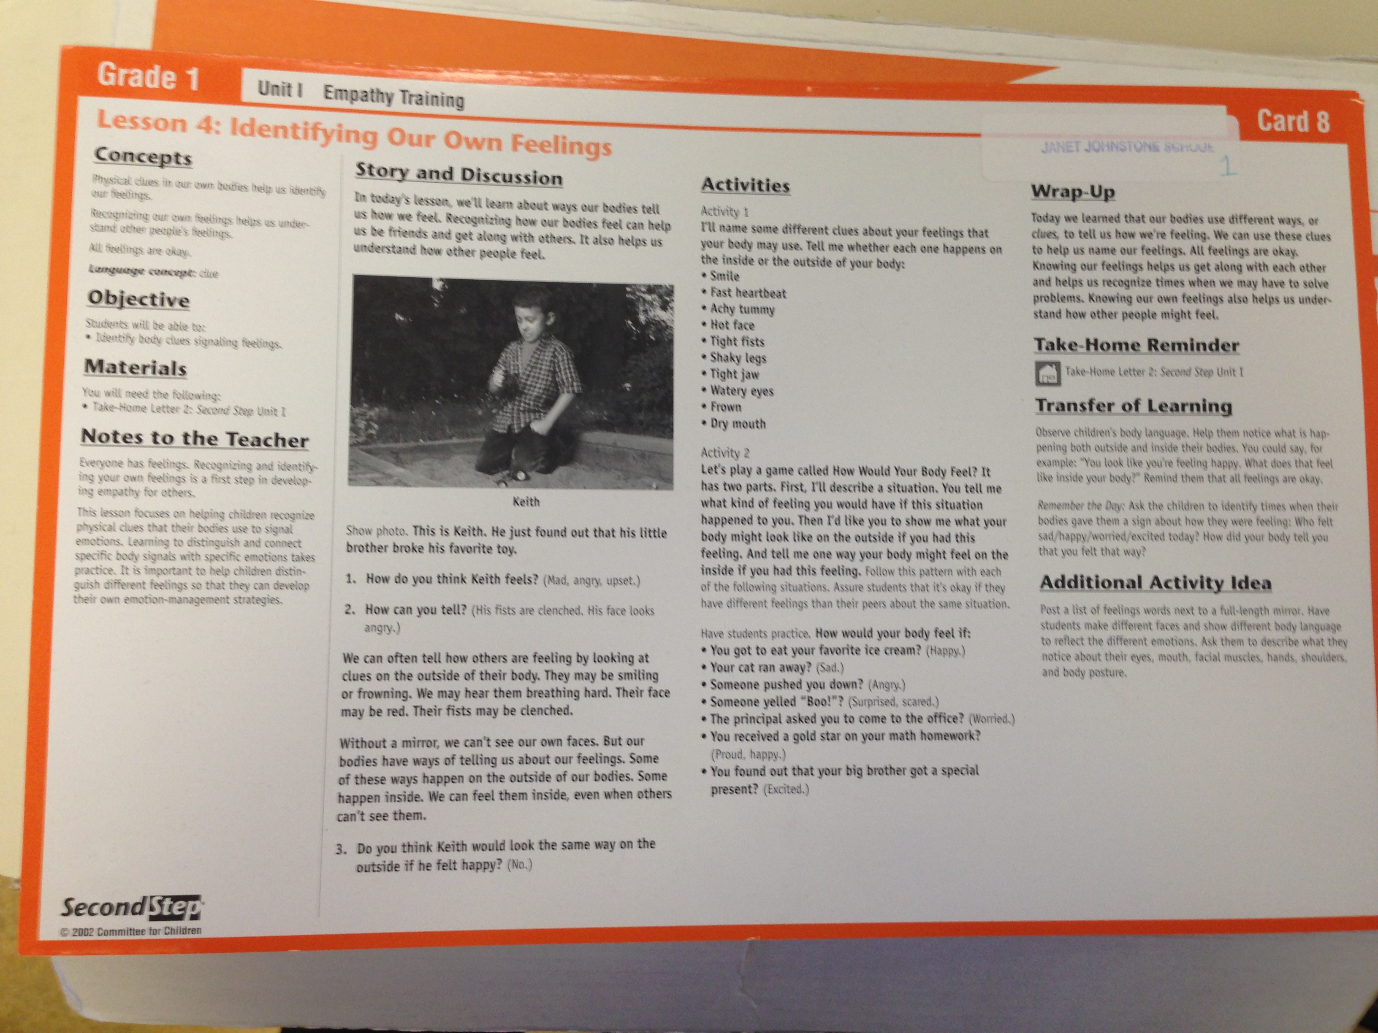

You get to eat your favourite ice cream.
How do you feel?

Your dog ran away.
How do you feel?

Someone pushed you down.
How do you feel?

Someone yelled “Boo”!
How do you feel?

The principal asked you to go to the office.
How do you feel?

You received a gold star on your math homework.
How do you feel?

You found out that your big brother got you a special present.
How do you feel?

It’s time for recess! You want to play on the swings, but when you get there all the swings are being used.
How do you feel?

You found out you’re going to Disneyland.
How do you feel?

You’re about to go on a roller coaster that goes really high and fast!
How do you feel?

You painted a pretty picture in art class and the teacher holds it up to show everyone.
How do you feel?

You’re about to meet your favourite superhero or princess.
How do you feel?

It’s the end of the day and all your friends have gone home with their parents, but you don’t know where your parents are?
How do you feel?

You just got a new puppy!
How do you feel?

