Lesson Title/Focus | Color Tag | Date | Monday November 18th
Subject/Grade Level | Physical Education – Grade 2/3 | Time Duration | 35 mins  (12:35-1:10pm)
Unit | Jump Rope | Teacher | Miss. Collier/ Mr. Cooke

OUTCOMES FROM ALBERTA PROGRAM OF STUDIES
General Learning Outcomes: | GENERAL OUTCOME A  Students will acquire skills through a variety of developmentally appropriate movement activities; dance, games, types of gymnastics, individual activities and activities in an alternative environment; e.g., aquatics and outdoor pursuits.  Basic Skills – Locomotor  GENERAL OUTCOME C  Students will interact positively with others.  Fair Play.
Specific Learning Outcomes: | A2–1 select and perform locomotor skills involved in a variety of activities.  A3–1 respond to a variety of stimuli to create locomotor sequences.  C2–3 / C3-3 identify and demonstrate etiquette and fair play
LEARNING OBJECTIVES
Students will:
- Perform a variety of locomotor skills.
- Demonstrate fair play.
ASSESSMENTS
Observations: |  |  | - Observations of how students participate in the activity.
Products/Performances: |  |  | - Color tag
LEARNING RESOURCES CONSULTED |  |  |  | MATERIALS AND EQUIPMENT
- Spark PE Resource  - Physical Education Program of Studies |  |  |  | - 4 Cones  - 8 Jump ropes at each station.  - 4 cones  - 4 color cards  - 4 skill cards  - 4 different colored soft balls/fluffs OR pinnies
PROCEDURE
Prior to lesson |  | Have equipment ready to be put out and skill cards ready.
Introduction |  |  |  |  | Time
Attention Grabber |  | Warm Up: Have students skip laps around the gym until equipment is set up for game. |  |  | 5 mins  12:35
Expectations for Learning and Behaviour |  | - Quietly listening to instructions  - Keep heads up and watch where you are going so you’re not running into people.  - Be aware of individual space. Watch where you are skipping so you don’t hit anyone.  - Be responsible and honest for your own actions. If you are tagged, go to the correct station. If you don’t know the station then just pick one. No tattle tailing if someone didn’t go to a station.  - Students who are playing fair and participating will be chosen to be the taggers.  - If there all the skipping ropes are being used at a station when you get there, do cross overs until a skipping rope becomes available.  - Review how to properly tag someone.  - When music stops – you stop and drop the ropes. There should be nothing in your hands.
Transition to Body |  | Ask all students to meet you in the middle of the gym when warm up/set up is finished.
Body |  |  |  |  | Time
Learning Activity #1 |  | EXPLAIN Color Tag: Explain rules and expectations. See attached game sheet for rules. Lay out the boundaries for the game (yellow square).  Ask students to repeat instructions back to you to make sure they are understanding. |  |  | 5 mins  12:40
Assessments/ Differentiation: |  | Observe how students listen to instructions.
Learning Activity #2 |  | PLAY Color Tag: Choose 4 students who are sitting quietly and paying attention to be the taggers. Start students off by walking. Every 4 mins change the locomotor skill (skipping, running, crab walk, gallop, bear walk, hopping, 2 foot jump, etc.) Change the taggers at this time. Choose taggers who are participating and showing fair play.  *If you see too many students at a station, walk over and tell them that they have a free pass and everyone gets to go back into the game. |  |  | 20 mins  12:45
Assessments/ Differentiation |  | Observe how students participate in the game.
Closure |  |  |  |  | Time
Assessment of Learning: |  |  | Have students meet back in the middle circle. 1-2-3 Eyes on me. Tell students that you want them to self evaluate themselves. Explain that a 1 is I didn’t do good today, 3 is I could have done better and 5 is I did fantastic.  Ask: Were you a team player today? Did you give your best effort? Did you listen to instructions? Were you honest when you got tagged?  Ask boys to collect equipment and bring to equipment room then line up. Ask girls to do 10 jumping jacks and then line up. |  | 5 mins  1:05

Reflections from the lesson
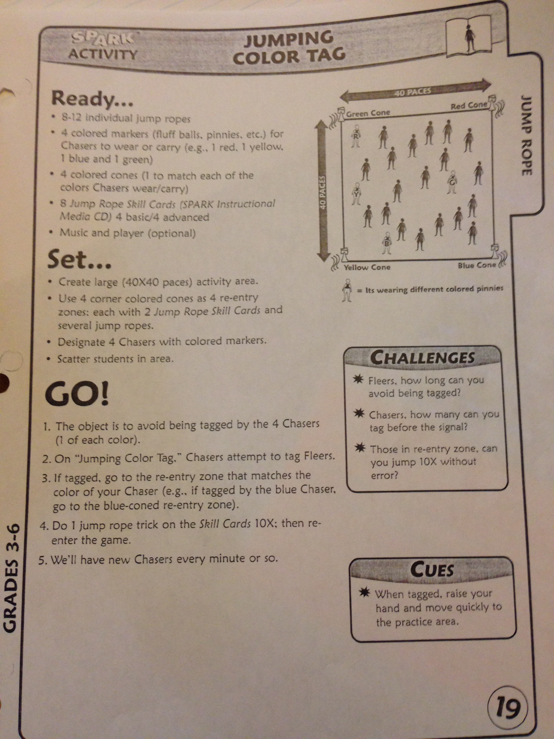

Jump Rope Skill:

1-Foot Hop

Challenge Yourself:

1-Foot Hop Backwards

Jump Rope Skill:

Skier

Challenge Yourself:

Side Straddle

Jump Rope Skill:

Single Jump

Challenge Yourself:

Single Jump Backwards

Jump Rope Skill:

Double Jump

Challenge Yourself:

Double Jump Backwards

