Physical Education
Unit Plan Assignment

Physical Education 10
Weight Training

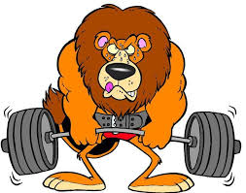

By: Darci Collier (001134633)
ED3601: Curriculum & Instruction – Physical Education
Submitted to: Brent Gammie
February 25th 2015

Table of Contents

Personal Philosophy 3
Introduction to Unit Plan 4
Unit Plan 6
Grading Description 8
Assessments
Weight Training Unit Quiz 9
Journal Entries Criteria/Questions 11
Participation & Self Evaluation Rubric 12
Hypothetical Student 13

Personal Philosophy of Physical Education

The purpose of physical education is to provide students with the opportunity to develop Physical Literacy. Physical Literacy can be defined as “the ability to move with competence and confidence in a wide variety of physical activities in multiple environments that benefit the healthy development of the whole person”. As a physical educator, I think it is crucial that I provide students with the skills and knowledge about movement, teamwork, communication, benefits of health, and daily physical activity so my students can strive to become successful in Physical Literacy.
My major focus is to make physical education class an enjoyable experience for all participants. This begins by providing a safe and comfortable learning environment. This occurs when every student feels physically, socially and emotionally safe. Openness and friendliness will be encouraged to reduce the fear of rejection and humility. Enthusiasm and respect are also foundations for building an enjoyable environment for everyone. I will expect to give each student the respect that they deserve, and in turn, receive the same amount of respect. To further develop respect and relationships, I hope that my students can challenge me as much as I challenge them, and as a result we can all learn from one another.
I can provide students with the skills and knowledge to live a healthy and active lifestyle, but ultimately it will be up to the student to be responsible and apply that information to their daily lives. Students will be encouraged to find individual ways that work best for them to stay healthy and fit in a safe manner, both physically and mentally. I will do my best to provide students, and their parents with information about how to get active at home and within the community to help encourage whole family participation.
As a physical educator, I think it is important that I demonstrate Leadership and be a role model for my students. This means I must practice what I preach. I must model a healthy active lifestyle for my students that correlates to what I am teaching them. This includes becoming an active participant within the activities I implement in my physical education class.
I believe in the importance of providing a variety of assessment methods and instructional strategies to accommodate the assortment of learning styles that every group of students provide. I will be aware of my students’ differences and create lessons for various ages and abilities. Through different instructional models, I will help students develop the skills and knowledge that they need to be physically active for life. I will provide opportunities for individual skill development, partner work, small group work and whole group activities. I will assess students through a variety of methods, including journals and reflections, self and peer evaluation, skill tests, quizzes, exit slips, simple class or small group discussion, group performances and demonstrations etc. I want to give students the best opportunity to demonstrate their skills, knowledge and understanding of what they are learning.
Overall, I want my students to learn the skills and knowledge of how to be active for life and translate that information into daily physical activity. I hope to inspire them and instil the same passion and drive that I have for physical activity.

Introduction of Unit Plan

The purpose and main idea of my unit plan is to educate my students with the proper techniques of lifting weights, using weight machines and overall working out, while also teaching them the benefits of health that go along with regular fitness activity. I chose to focus on benefits of health and body image because I believe that these are areas that are relevant and are essential information for grade ten students to consider and learn about.
There are many outcomes that my unit plan is focused around. Incorporated throughout the unit plan is the basic knowledge and fundamental skills of weight lifting to benefit ones self. These skills also target the benefits of being physically active in daily life. Another major area of focus is proper etiquette and safety throughout the weight room. There are many different rules and routines that come along with lifting weights and working out. I want to make sure my students have the proper knowledge and safety considerations while they’re working out so they can reach their full potential while avoiding the chance of injury. Leadership is also a big area I want to focus on throughout my unit. If I can be a role model for leadership and teach my students how to be leaders in physical activity and fitness then it may set a foundation for my students to live a healthy lifestyle on a daily basis. I hope that they value being physically active and be advocates for fitness in the future.
My unit plan correlates with my teaching philosophy in a variety of ways. My first aim is to have meaningful teaching. Teaching my students the proper techniques and safety of physical fitness is important, but understanding WHY we need to be physically active is even more important. I want my students to understand the reasons why being physically fit and active is important in living a healthy lifestyle. I think that if students understand why it is so important, they might feel more obligated to participate and enhance their understanding. I also want to display leadership to my students and be an advocate and role model for physical activity. Obesity is on the rise amongst youth and I believe that if I can increase my student’s awareness and give them the tools and skills they need to live active lives, by displaying it myself as a role model, then this will hopefully translate and impact more and more people. I think that being an advocate and role model for physical health and well-being will be more beneficial to my students in the long run. I also believe that student responsibility is a main focus within my unit plan. I can go on and on about the benefits of physical activity and fitness, but ultimately it is up to the students to take responsibility and initiative and demonstrate their understanding of the concepts I am teaching them. I can give them the tools they need to succeed, but it will be up to them to implement that knowledge into their daily lifestyles.
I provide a variety of assessments, both formative and summative throughout my unit plan. I believe that assessment techniques within Physical Education should be fairly quick and basic. Quick assessment allows us to maximize time spent participating in activity, and basic assessment provides an opportunity for students to show me their knowledge without the assessment being too easy or too hard, which can lead to some discouraged or unchallenged students. Students should be able to engage their learning within the curriculum material. My formative assessments will consist of basic observation of how kids are participating, cooperating and demonstrating their knowledge through skill development, a workout log where students will track what exercises they are performing and how much weight/reps/sets are involved, self-evaluation, which allows the student the opportunity to assess their own participation and efforts put forward throughout class. and overall small group and whole group discussion, mostly question and answer. My summative assessments will consist of three different concepts. Journal entries where I will provide students with a question relevant to the information taught that day and they must give me a short response to demonstrate the knowledge they have obtained throughout lecture material and skill development. A very short quiz will be completed on the last day of the unit to show me what information the students have obtained overall throughout the unit. Lastly, participation will be graded because showing up to class prepared to be active and participating in the activities is a huge component of physical education.
Even though this unit is short, I feel that my students will see some improvements in their fitness levels and strength in the few days we spend in the weight room. I also believe that these days spent weight training will give my students the foundational knowledge they need to plan their own work outs and make safe choices within the weight room.
Grade: Physical Education 10 Unit: Weight Training Dates: March 23 – 26 Class Duration: 86 mins
Lesson Number | Lesson Title | GLO’s | SLO’s | Learning Activities | Assessment | Safety | Instructional Strategies | Equipment | Motivation
1  March 23 | Introduction to the Weight Room | A  C  D | A10-13  C10-3  C10-4  D10-3 | 1.Walk around the Weight room, demonstrating the different machines and why we use different machines and free weights to work out.  2.Discuss proper safety and etiquette  3.Students will then take the rest of the class to experiment and work out in partners.  4. Students will complete a short journal entry at the end of class. On their way out of class they will give the teacher a self-evaluation out of 5 for that day. | Observation  Self Evaluation  Journal Entry  Exercise Log Sheet | Outline all safety regulations that must be taken while working out (someone spotting, over lifting, proper technique, potential hazards)  Awareness of Others – Working with each other. No bullying or exclusion. | Direct Instruction  Guided Discovery  Cooperative Learning | Weight Room | Positive Reinforcement  Modeling  Music
2  March 24 | Benefits of Health  &  Circuit  Training | A  B | A10-3  B10-6 | 1.Brief lecture and discussion on the benefits of health by being physically active for life and how we can be physically active in the community.  2.Students will partner up and make their way through a circuit training course.  3. Students will complete a short journal entry at the end of class. | Observation  Discussion  Journal Entry  Exercise Log Sheet | Safety regulations while in the weight room.  Awareness of others | Direct Instruction  Cooperative Learning  Fitness for Life Model | Weight Room | Positive Reinforcement  Modeling  Achievement Goals  Moral Development  Music
3  March 25 | Body Image | A  B | A10-13  B10-4 | 1.Brief PowerPoint and discussion about body image and the expectations of society. What is wrong with those expectations?  2.Critical thinking when seeing different false advertisements.  3.Students will get into partners and use the rest of class time to complete their work outs.  4. Students will complete a short journal entry at the end of class. | Observation  Discussion  Journal Entry  Exercise Log sheet | Safety regulations while in the weight room.  Awareness of others | Direct Instruction  Cooperative Learning  Fitness for Life Model | Weight Room | Positive Reinforcement  Modeling  Achievement Goals  Personal Values  Music
4  March 26 | Final Fitness Day -  Fitness BINGO | A | A10-13 | 1.Quick explanation of how to do Fitness BINGO.  2.Students will get into partners and work on Fitness BINGO.  3. With 20 minutes left of class, students will complete a quiz. At the end of the quiz students will self-evaluate their efforts throughout the unit. | Observation  Exercise Log Sheet  Self Evaluation  Quiz | Safety regulations while in the weight room.  Awareness of others | Direct instruction  Cooperative Learning  Guided Discovery | Weight Room | Positive Reinforcement  Modeling  Achievement Goals  Music

Grading Description

Unit Plan Grading Criteria Breakdown:
Quiz 20 %
Journal 20%
Participation 60%
Total 100%

*This unit is worth 10% of overall grade

Summative Assessment Breakdown:
Quiz – 20%
A quiz will be provided on the last day of the unit for students to complete. This quiz will be worth 20% of the student’s final grade for this unit. It will assess what knowledge the students have gained from the lecture material that was presented throughout the unit. It targets all of the Physical Education General Outcomes (A, B, C, D).

Journal – 20%
Students will complete regular journals in the last 10 minutes of class. These quick and basic journals will allow me to see how students can demonstrate specific knowledge related to lecture material provided that day. Students will be able to make connections to real-life experiences/situations. Journals will be out of 10 marks each. Overall for this unit, journals will make up 20% of the students mark. Journals will target General Outcomes B, C and D.

Participation – 60%
Participation for the Weight Training unit will make up 60% of the students final unit grade. It is key that for students to reach their full potential in physical education, students come prepared in proper attire, demonstrate sportsmanship and teamwork, follow directions, demonstrate proper safety techniques (especially while in the weight room), challenge themselves, give 100% effort, and are self-motivated and enthusiastic throughout activities. The rubric provided breaks down participation into all four physical education outcomes – Outcome A = Activity/Skills/Participation, Outcome B&C = Benefits of Health & Cooperation and Outcome D = Effort.

Assessments

WEIGHT TRAINING UNIT QUIZ
Physical Education 10 (3 Credit)
/25 marks

Directions:
- Complete the quiz to the best of your ability and read each question carefully.
- Raise your hand if you have any questions about the quiz.
- You have 20 minutes to complete this quiz.
- When finished, please hand quiz into teacher.

Fill in the Blank – Please read each question carefully. Write your answer in the blank space provided.
1. Youth aged 12-17 years should accumulate at least _______________
minutes of moderate to vigorous intensity physical activity daily to see optimal
health benefits. (1 mark)
2. Childhood _______________ in Canada has tripled over the past three
decades because of an increase in _______________ lifestyles. (2 marks)

Short Answer – Please read each question carefully. Point form is acceptable.

3. Physical activity, which contributes to all health related components of physical fitness can develop and maintain certain aspects of one’s health. Identify four health problems less likely to occur as a result of a personal fitness program (4 marks)

1.

2.

3.

4.

4. List and explain two common reasons/excuses someone would give for not participating in a weight training program. (4 marks)

1.

2.

5. List three rules of safety for the weight room and explain why they are important. (6 marks)

1.

2.

3.

6. Here are some exercises that were performed throughout your weight training programs. Name the part of your body where these exercises are working. Try and be as specific as possible (5 marks)

1. Sit ups - _______________________________________________________
2. Leg press – ____________________________________________________
3. Bent over row – _________________________________________________
4. Squat - ________________________________________________________
5. Dumbbell curl - __________________________________________________

True or False - Please read each question carefully. Circle T for True or F for False.

7. T / F Physical activity plays an important role in the health, well-being
and quality of life of Canadians. (1 mark)

8. T / F Both men and women experience self-consciousness in regards to their body image. (1 mark)

9. T / F An increase in the sexualization of advertisements has decreased the rate of eating disorders and body image issues among teenage girls. (1 mark)

JOURNAL ASSESSMENT CRITERIA
/ 10 MARKS (2 marks each)

CRITERIA | YES | NO | COMMENTS
Provides a response that is consistent with what is being asked in the question.
Written in first person.
Expresses views, ideas and emotions.
Shows insights by applying information to real world situations.
Clear, Concise and Organized thoughts

Journal Questions
(To be provided to students each day)

Day 1: Introduction to Weight Training:
Briefly explain why safety, proper etiquette and proper technique are so important within the weight room. List as many rules as possible that were discussed today.

Day 2: Benefits of Health & Circuit Training:
Explain what kind of benefits you will receive from participating in regular Weight Training activities.
What did you like/dislike about the circuit training? Would you improve anything in the circuit? Why or why not?

Day 3: Body Image:
Discuss your thoughts about medias portrayal of body image. Do you think society is sending the right idea to adolescents about their bodies? Is it realistic or unrealistic? Why? What advice could you give to a friend who was having self-esteem issues about their body?

PHYSICAL EDUCATION PARTICIPATION RUBRIC

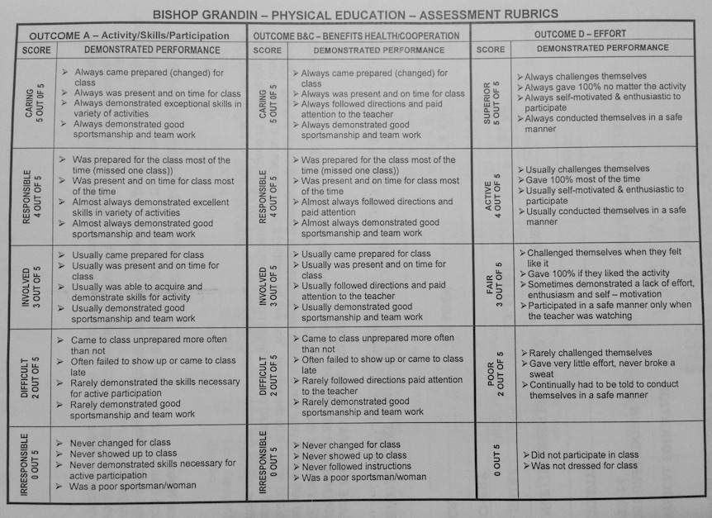
Hypothetical Student

Quiz:
Sally received the following grade on her Weight Training Unit Quiz:

20/25 = 80%

0.80 x 20% = 16/20 Sally will receive 16% out of a possible 20% towards
her final grade for her unit quiz

Journals:

Day 1: Introduction to Weight Training:
Briefly explain why safety, proper etiquette and proper technique are so important within the weight room. List as many rules as possible that were discussed today.

CRITERIA | YES | NO | COMMENTS
Provides a response that is consistent with what is being asked in the question. | √
Written in first person. | √
Expresses views, ideas and emotions. | √
Shows insights by applying information to real world situations. | √
Clear, Concise and Organized thoughts | √
Total: 10/10

Day 2: Benefits of Health & Circuit Training:
Explain what kind of benefits you will receive from participating in regular Weight Training activities.
What did you like/dislike about the circuit training? Would you improve anything in the circuit? Why or why not?

CRITERIA | YES | NO | COMMENTS
Provides a response that is consistent with what is being asked in the question. | √
Written in first person. | √
Expresses views, ideas and emotions. | √
Shows insights by applying information to real world situations. | √
Clear, Concise and Organized thoughts | √
Total: 10/10

Day 3: Body Image:
Discuss your thoughts about medias portrayal of body image. Do you think society is sending the right idea to adolescents about their bodies? Is it realistic or unrealistic? Why? What advice could you give to a friend who was having self-esteem issues about their body?

CRITERIA | YES | NO | COMMENTS
Provides a response that is consistent with what is being asked in the question. | √
Written in first person. | √
Expresses views, ideas and emotions. | √
Shows insights by applying information to real world situations. | √
Clear, Concise and Organized thoughts | √
Total: 10/10

30/30 = 100%

100% x 20% = 20/20 Sally will receive 20% out of a possible 20% towards her final
unit grade for her journals.

Participation:

5/5 5/5 4/5

Total: 14/15 = 93%

0.93 x 60% = 56% Sally will receive 56% out of a possible 60% for the
participation component of her final unit grade.

Final Unit Grade Breakdown:
Sally’s Grade:
Quiz 20 % 16%
Journal 20% 20%
Participation 60% 56%
Total 100% 92%

Sally will receive 92% for her Weight Training Unit final grade.
This unit is worth 10% of her final Physical Education 10 grade.

